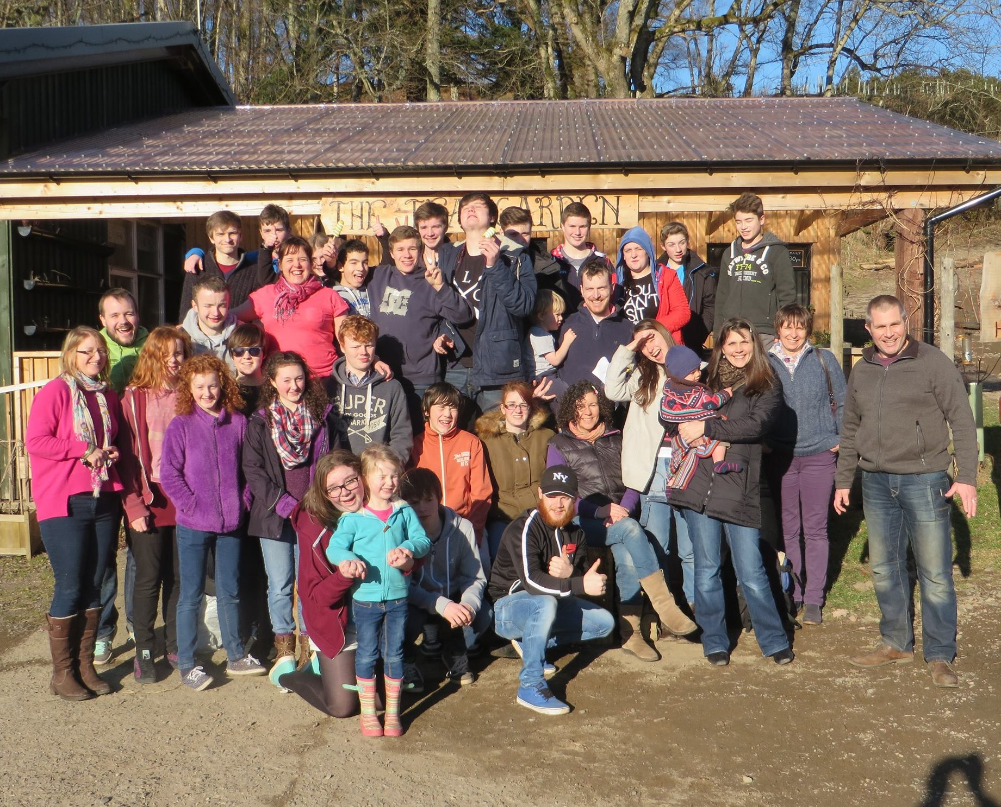  - 23-25 February  Connections 2018  For youth (12-17)  Connections 2018 is taking place at a NEW venue this year – the Windmill Christian Centre in the sunny seaside town of Arbroath! We’re excited about taking this annual event to a new location and believe God has some great things lined up for us!  So, join us for another jam-packed weekend full of fun, worship and teaching, enjoying God, hanging out with old friends and making new ones. Over the years we have witnessed many young people discover the Father’s love in a new way, sometimes for the first time, and their destiny and role in seeing His kingdom come here on earth. Our desire is to see the same this year. We look forward to seeing you on 23rd February!  * The early bird booking fee of £50 will increase to £60 from 19th January 2018. Fees will not be refunded if cancellation is made 14 days or less prior to the event. |  | Early bird offer: £50*, including accommodation & food  Fantastic activities indoors & outdoors!  Helping young people discover their destiny in Christ  ‘Like’ us on: www.Facebook.com/  connectionsweekend  Arrival time: 6pm Friday  Departure time: 2pm Sunday  Departu  ANY QUERIES CONTACT:  Emma Davies Emmajdavies77@gmail.com  M: 07963 817302
PARENTAL CONSENT FORM

This form must be completed by the parent/guardian with the ‘early bird’ £50 payment made by 19th January 2018 to secure a place. Please note the price will increase to £60 after this time. The deadline for booking is 11th February 2018.

The Connections weekend is in February so please bring appropriate outdoor clothing. Please find the suggested ‘kit list’ to follow.

Full Name of Young Person:………………………..…..…………………………… Date of birth:…………….…….

Address: …………………………………………………………………..…………………………………………………

Postcode: ………..……………… Home Tel. No.: ………………………… Church :…………………………………

Parent(s)/guardian(s) info: Names: 1. …………………………………… 2. …………………………………….

Parents mobile phone nos: 1. ………………………………….. 2. ………………………………………..

Alternative emergency contact: Name:………………………………. Tel. no. ……………………………………….

About your son/daughter:

Any known medical conditions (including allergies, special dietary restrictions etc): ………………………………

…………………………………..…………………………………………………………………………………………….

Medication using at present: ………………………………………………………………………..……………………..

Do they require a leader to ensure this medication is taken? Yes No

Name of Doctor: …………………………………………….………….. Tel. No.:……………………………

Address:………………………………………………………………………………………………………………….
LEADER’S FORM
The weekend is in February so please bring appropriate warm outdoor clothing. Please find the suggested ‘kit list’ to follow.

Full Name:………………………..…..…………………………… Church :……………………..……………

Address: …………………………………………………………………..…………………………………………………

Postcode: ………..……………… Home Tel. No.: ………………………………………..

E-mail:………………………………………………………………….

SUGGESTED KIT LIST
Please note there will be some outdoor activities.
- Bible, pen and notebook
- Baselayer tops or T-shirts (more than 1)
- Midlayer tops or fleeces (more than 1)
- Jumpers
- Warm Trousers
- Walking Boots
- Warm Socks (several pairs)
- Waterproof Jacket
- Waterproof Overtrousers (If you have them)
- Hat
- Gloves
- Wash Kit
- Towel
- Spare Underwear
- Spare Socks
- Spare Pair of Trainers (depending on conditions)
- Torch
- Cakes/traybake to share
- Bedlinen (pillowcase, fitted sheet & duvet cover) – alternatively you can hire this at the venue for £6.

